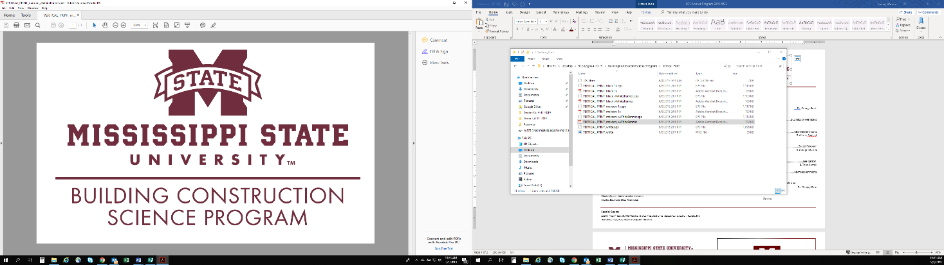

**Building Construction Science Program**

**2019 Awards Banquet**

**Sponsored by**

The Building Construction Science Program and

Industry Advisory Board

**PROGRAM**

Reception and Buffet Dinner

Welcome and Introductions.…………………….…………………………………….Dr. George Ford

2018-2019 Academic Year Overview……………………………………...BCS Faculty Members

Toast to the Building Construction   
Science Class of 2019…………………………...………………………………..…..Michele Herrmann

& Ali Shojaei

Associated Schools of Construction Competition………………………………Saeed Rokooei

& George Martin

Associated Builders and Contractors (ABC) Student   
Chapter Awards………………………………………………………………………………………Lee Carson

& Tony Carroll

Academic Scholarship Recipients…….……………………………………....…Michele Herrmann

Recognition of the 2018-2019 Students of the Year Recipients and  
the 2019 BCS Director’s Medallion Recipient.………………………….……...Dr. George Ford

Closing

**Industry Advisory Board Members**

Associated Builders and Contractors (ABC) Jesco Inc. Construction

Core Construction Lemoine Company

Adams Group Lipsky Enterprises, Inc.

Brasfield & Gorrie LLC Mississippi Construction

Brislin, Inc. Education Foundation

Clark Construction Montgomery Martin

Copeland & Johns Probity Contracting Group

Dale Partners Architects Pryor & Morrow Architects

F.L. Crane & Sons R. C. Mathews

Fisher Brown Bottrell Roy Anderson

Gipson Steel Sanderson Construction, Inc.

Glass, Inc. Turner Construction, Inc.

Graham Roofing Upchurch Plumbing

Hoar Construction White Construction

Innovative Construction Management Yates Construction

**Program Director**George Ford, Ed.D., Director and Professor

**2018-19 BCS Faculty**

Michele Herrmann, Esq., Assistant Professor Ashley Weekly, Lecturer  
Saeed Rokooei, Ph.D., PMP, LEED AP John Robertson, Lecturer  
Lee Carson, Assistant Clinical Professor Jim West AIA, Professor

Ali Shojaei, Ph.D., Assistant Professor Briar Jones AIA, Lecturer  
George Martin, Visiting Associate Professor Edward Kemp PE, Lecturer

**Staff**

Windie Speed, Administrative Assistant  
Charles Beckham, Shop Technician

**Special Guests**

Joel A. “Tony” Carroll, IAB Member & Vice President of Sanderson Construction, Tupelo, MS

Hunter Bullock, ABC Student Chapter President



Mississippi State University

Building Construction Science Program

**2019 Awards Banquet**

May 2, 2019 | 6:00 P.M.

The Mill | Starkville, Mississippi

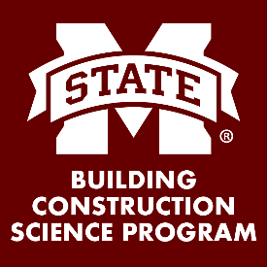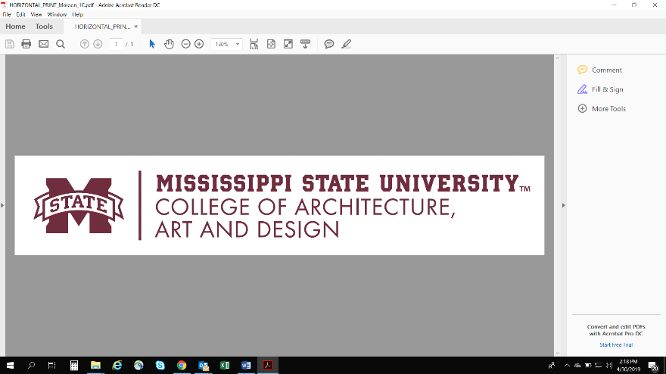

BUILDING CONSTRUCTION SCIENCE PROGRAM

2018-2019 AWARD AND SCHOLARSHIP RECIPIENTS

***Director’s Medallion\****To be Announced

***Students of the Year***

First Year………………………………………….……………………….…William Martin

Second Year………………………………….…………………..……….....Curtis Wilson

Third Year…………………………………………….…………Victoria Ann Thompson

Fourth Year………………………………………………………...…………..Evan Hodges

***Scholarship Recipients***

Katherine Pistritto, Kline Mechanical Systems Annual Scholarship

Troy Stokes, MS Associated Builders & Contractors Scholarship

Victoria Ann Thompson, Abbey Burnett Bridges Endowed Scholarship

Micky Mangan, Chip & Jennifer Crane Endowed Scholarship

Eric Talley, MS Contractors Endowed Scholarship

Jalyn Wallin, Brislin, Inc. Annual Scholarship

Christopher Sharp, Brislin, Inc. Annual Scholarship

Kacie Lynn James, Brislin, Inc. Annual Scholarship

Zachary Taylor, Brasfield & Gorrie Building Construction Scholarship

*Director’s Medallion recipient is selected by the Faculty based upon grade point average, service, and leadership.